**PIZZA SALES SQL QUERIES**

**A)KPI’s**

**1. Total revenue**

select

sum(total_price) as revenue

from

pizza_sales;

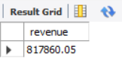

**2. Total orders**

select

count(distinct order_id) as total_orders

from

pizza_sales;

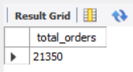

**3. Average order value**

SELECT

(SELECT

SUM(total_price)

FROM

pizza_sales) / (SELECT

COUNT(DISTINCT order_id)

FROM

pizza_sales) AS avg_order_value;

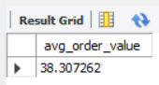

**4. Average pizzas per order**

select

(select sum(quantity) from pizza_sales)/(select count(distinct order_id) from pizza_sales) as avg_pizzas_per_order;

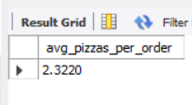

**5.Most ordered pizza**

select pizza_name, count(pizza_name) total from pizza_sales group by pizza_name order by total desc limit 1

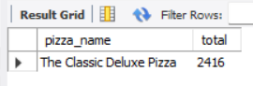

**6. Total number of pizzas orders on each day of the week.**

select dayname(order_date) as day, count(*) as no_of_pizzas_ordered from pizza_sales group by day order by

case

WHEN Day = 'Monday' THEN 1

WHEN Day = 'Tuesday' THEN 2

WHEN Day = 'Wednesday' THEN 3

WHEN Day = 'Thursday' THEN 4

WHEN Day = 'Friday' THEN 5

WHEN Day = 'Saturday' THEN 6

when day = 'sunday' then 7

end asc;

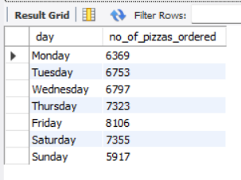

**B) Chart’s requirements**

**1.Daily trends for total orders**

select dayname(order_date) as day, count(distinct(order_id)) as total_orders from pizza_sales group by day;

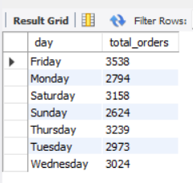

**2.Monthly trends of total orders.**

select

monthname(order_date) as month,

count(distinct(order_id)) as total_orders

from

pizza_sales group by month;

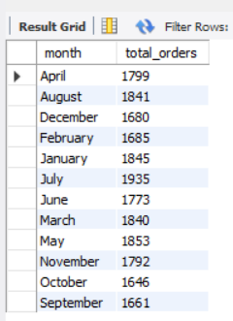

**3. Percentage of sales by size**

SELECT

pizza_size,

SUM(total_price) * 100 / (SELECT SUM(total_price FROM pizza_sales

AS percent

FROM

pizza_sales

GROUP BY pizza_size;

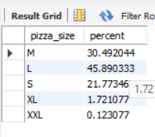

**4.Percentage of sales by pizza category**

select pizza_category, sum(total_price)*100/(select sum(total_price) from pizza_sales) as percent from pizza_sales group by pizza_category;

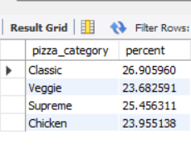

**5. Top 5 pizzas by revenue**

SELECT

pizza_name, SUM(total_price) AS revenue

FROM

pizza_sales

GROUP BY pizza_name

ORDER BY revenue DESC

LIMIT 5;

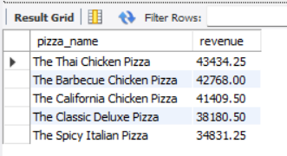

**6. bottom 5 pizzas by revenue**

SELECT

pizza_name, SUM(total_price) AS revenue

FROM

pizza_sales

GROUP BY pizza_name

ORDER BY revenue asc

LIMIT 5;

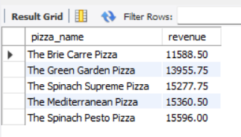

**7. top 5 pizzas by quantity**

SELECT

pizza_name, SUM(quantity) AS total_quantity

FROM

pizza_sales

GROUP BY pizza_name

ORDER BY total_quantity desc

LIMIT 5;

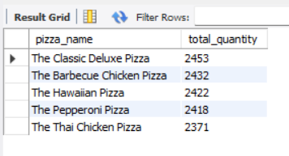

**8. bottom 5 pizzas by quantity**

SELECT

pizza_name, SUM(quantity) AS total_quantity

FROM

pizza_sales

GROUP BY pizza_name

ORDER BY total_quantity asc

LIMIT 5;

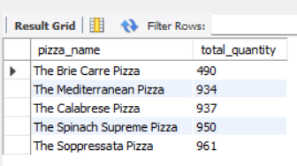

**9. top 5 pizzas by total orders.**

SELECT

pizza_name, COUNT(DISTINCT order_id) AS total_orders

FROM

pizza_sales

GROUP BY pizza_name

ORDER BY total_orders DESC

LIMIT 5;

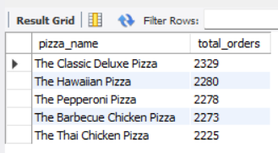

**10. bottom 5 pizzas by total orders.**

SELECT

pizza_name, COUNT(DISTINCT order_id) AS total_orders

FROM

pizza_sales

GROUP BY pizza_name

ORDER BY total_orders asc

LIMIT 5

